**Architectural Design**

* We are using **Model View Controller** as our architectural design for this project.
* **Basic MVC model:**

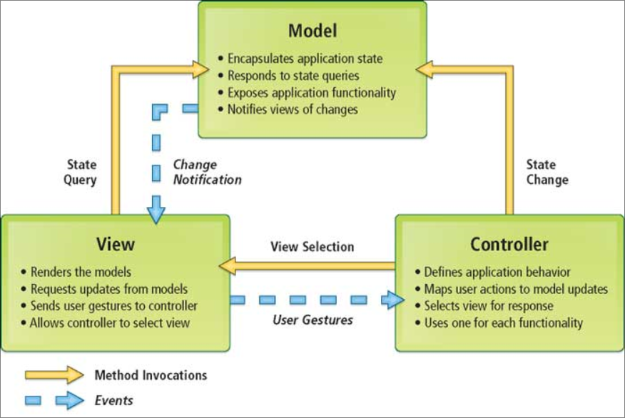

**MVC model for our project:**

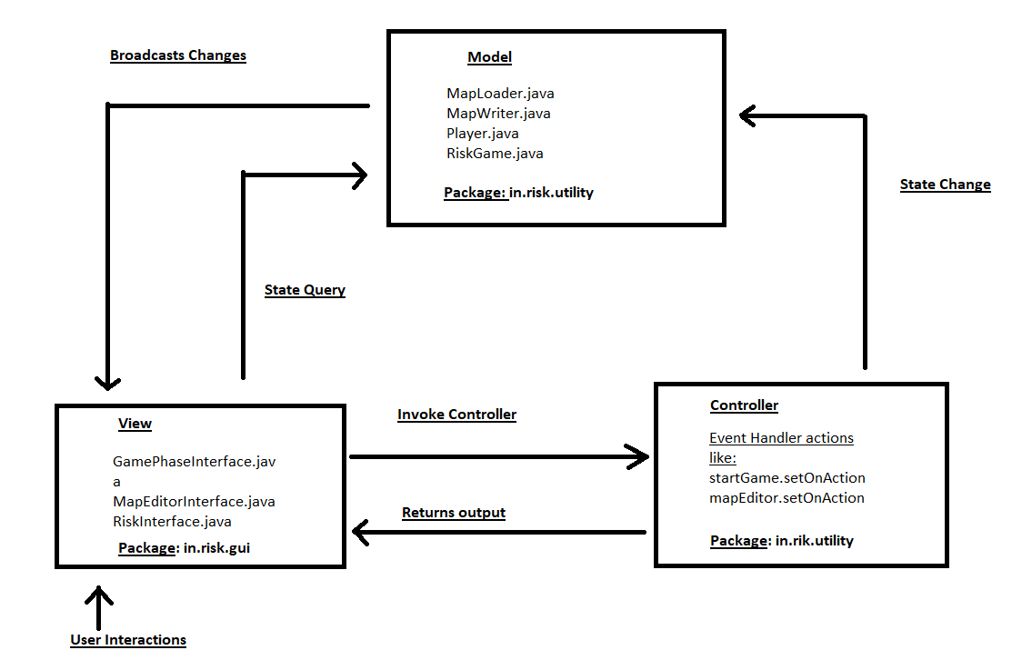

**View:**

* **Consist of all the files related to user interface. User interaction can be like button click, scroll bar, mouse click and others.**

**Module Structure:**

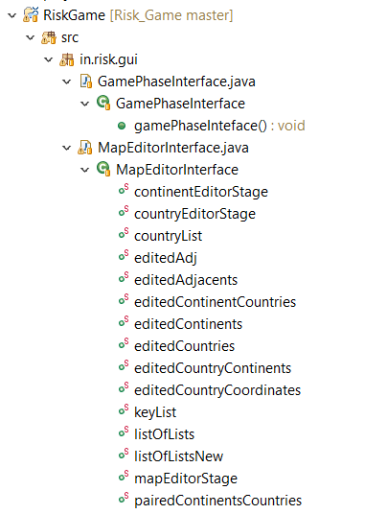

**Controller:**

* **Consists of all the file related to control operations like event handling, sending control to either model for more operations or to view directly**

**Module Structure:**

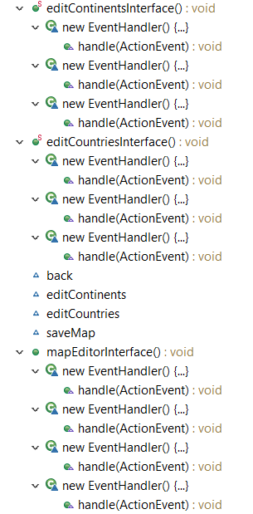

**Model:**

* **Consist of all the files which are responsible for performing necessary actions on data sent by controller and also broadcasts changes to view whenever required.**

**Module structure:**

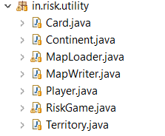

**Interaction between MVC model:**

* **User interactions like button click or mouse clicks are captured via view model.**
* **After receiving user interactions by view model, it will invoke controller via event handling methods.**
* **Controller can either send it to model for specific operations like calling various methods or**

**can send directly to view in the form of pop up screen or any event.**

* **Model after performing necessary operation will broadcast changes to view.**

**Event method handling and calling methods example:**

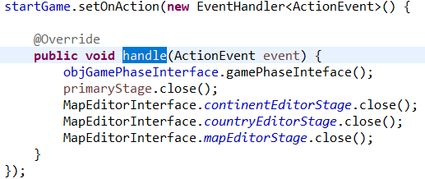

**Model performing necessary operations and broadcasting it to view example:**

